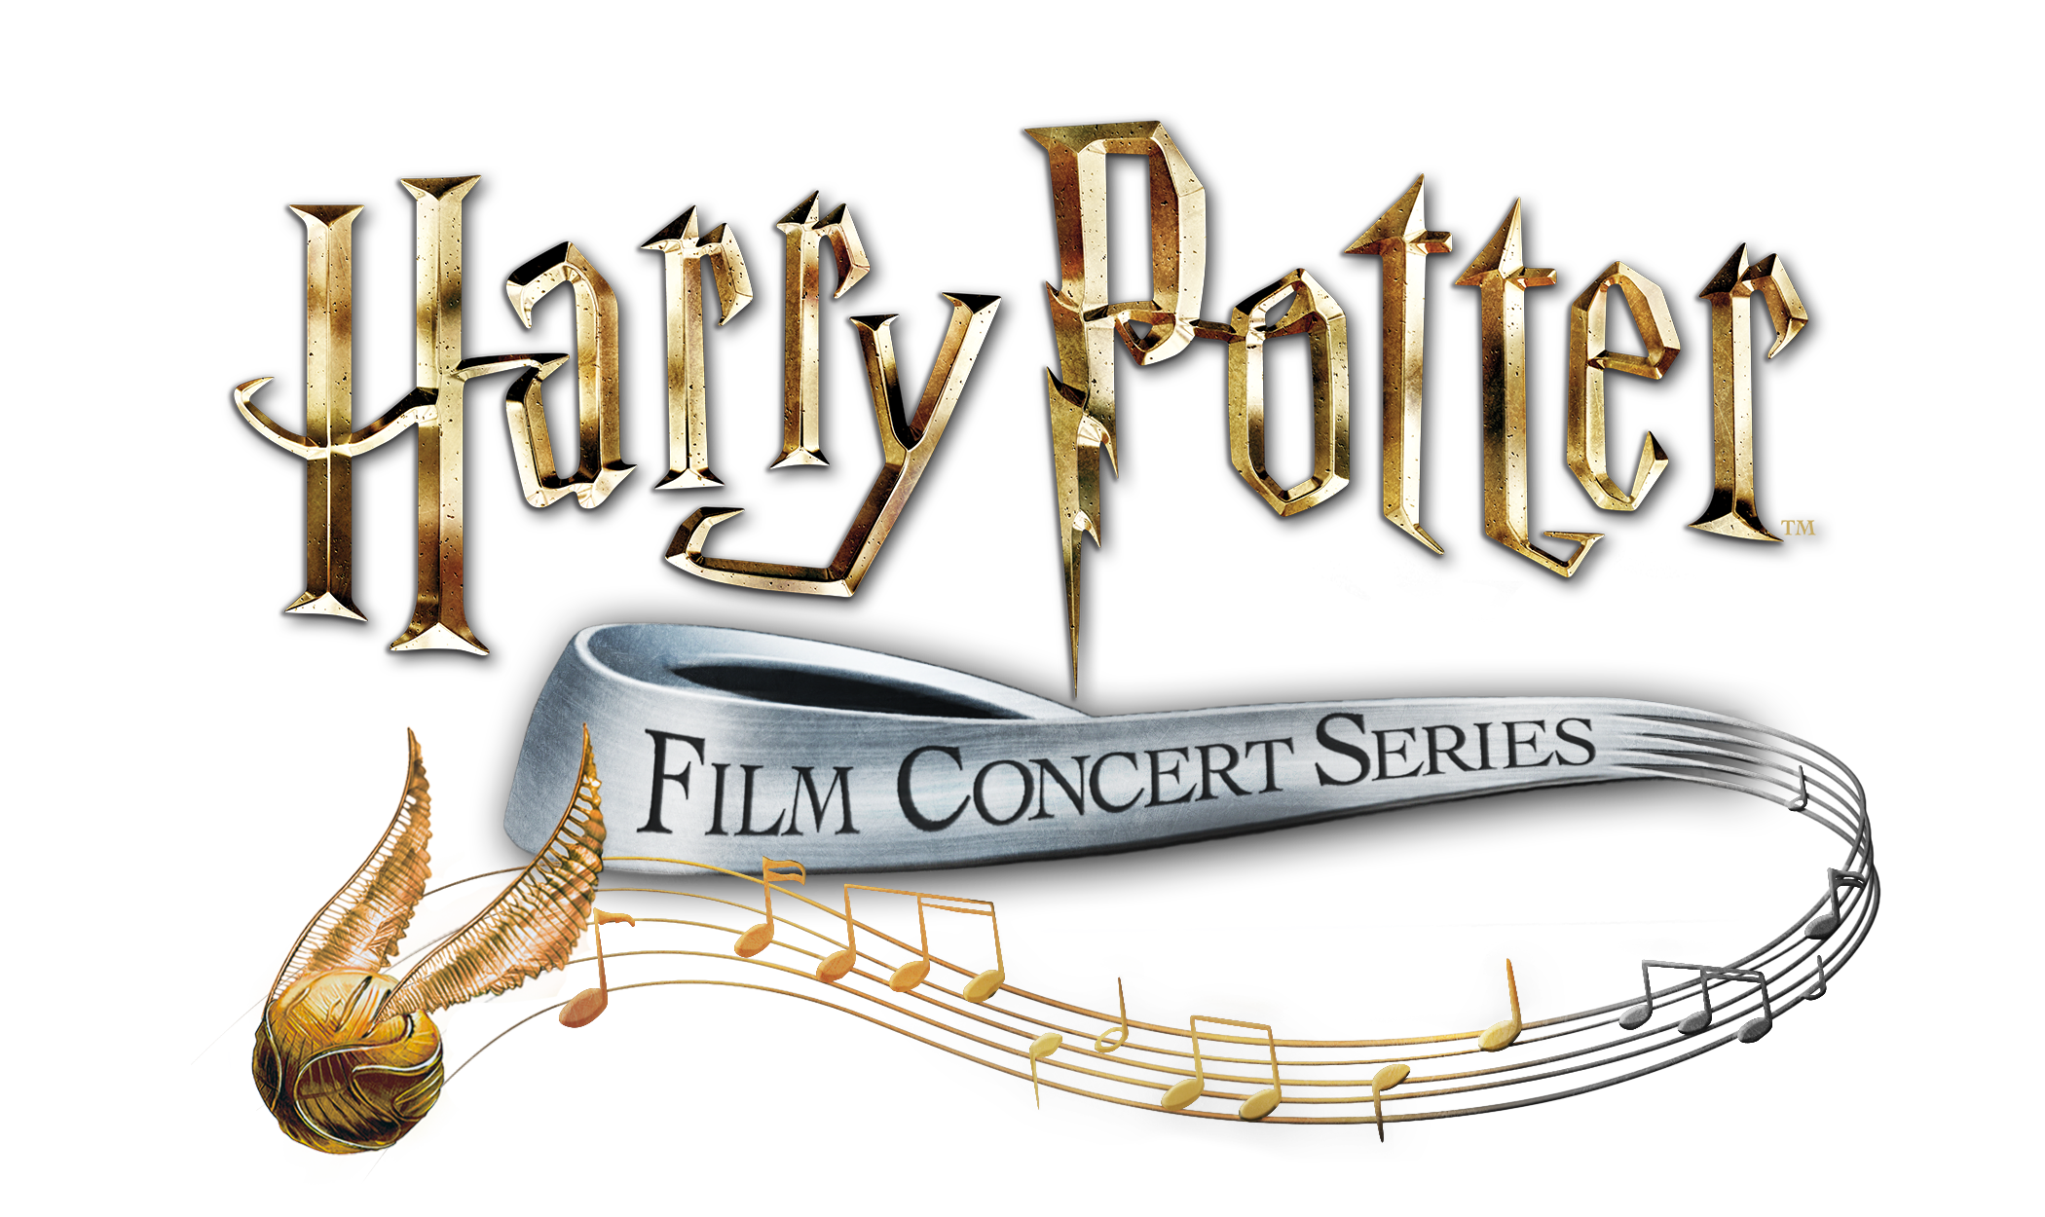

ICELAND SYMPHONY ORCHESTRA ANNOUNCES THE OFFICIAL HARRY POTTER FILM CONCERT SERIES, OPENING WITH HARRY POTTER AND THE PHILOSOPHER’S STONE™ IN CONCERT

For the first time in Harpa concert hall, audiences will experience the Iceland Symphony Orchestra performing John Williams’ music to the entire first film live to picture from one of the most beloved film series in history

TRAILER (Philosopher’s)

Tickets available now at sifonia.is and hapra.is

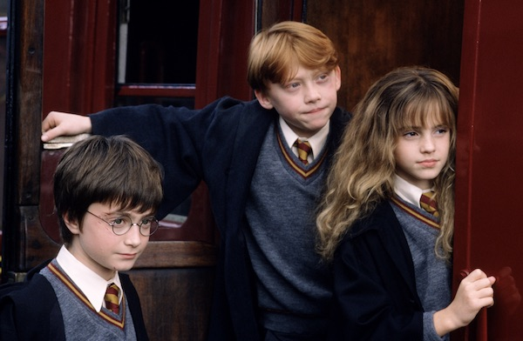
(20th October - Reykjavík) Iceland Symphony Orchestra announced today that the orchestra will perform Harry Potter and the Philosopher’s Stone in Concert on 25th, 26th and 27th of November as part of the official Harry Potter Film Concert Series. The concert will feature Timothy Henty conducting the Iceland Symphony Orchestra in performing live, to picture, every note from Harry Potter and the Philosopher’s Stone. Audiences will be able to relive the magic of the entire film in high-definition on a 40-foot screen while hearing the Iceland Symphony Orchestra perform John Williams’ unforgettable score live. Tickets are on sale now via sinfonia.is, harpa.is and +354 528 5050.

In 2016, CineConcerts and Warner Bros. Consumer Products announced the Harry Potter Film Concert Series, a global concert tour celebrating the Harry Potter films. Since the world premiere of Harry Potter and the Philosopher’s Stone in Concert in 2016, more than 2.7 million fans have enjoyed this magical experience from the Wizarding World, which is scheduled to include over 1,295 performances across more than 48 countries worldwide through 2021.

In Harry Potter and the Philosopher’s Stone, Harry Potter learns on his 11th birthday that he is the orphaned son of two wizards and possesses magical powers of his own. At Hogwarts School of Witchcraft and Wizardry, he learns the high-flying sport of Quidditch and plays a thrilling ‘live’ chess game en route to facing a Dark Wizard bent on destroying him.

Justin Freer, President of CineConcerts and Producer/Conductor of the Harry Potter Film Concert Series explains, "The Harry Potter film series is a once-in-a-lifetime cultural phenomenon that continues to delight millions of fans around the world. It is with great pleasure that we bring fans for the first time ever an opportunity to experience the award-winning music scores played live by a symphony orchestra, all while the beloved film is simultaneously projected onto the big screen. This is truly an unforgettable event.”

Brady Beaubien of CineConcerts and Concert Producer for the Harry Potter Film Concert Series added, “Harry Potter is synonymous with excitement around the world and we hope that by performing this incredible music with the full movie, audiences will enjoy returning to the Wizarding World.”

For more information on the Harry Potter Film Concert Series, please visit
www.harrypotterinconcert.com.

###
The Iceland Symphony Orchestra is the national orchestra of Iceland and one of the leading institutions on the country's cultural scene. Widely praised for its performances and recordings, the orchestra presents a full season each year of subscription series, school and family concerts, and concerts devoted to modern music. The Iceland Symphony is the resident orchestra in Reykjavík's award-winning Harpa Concert Hall.
About CineConcerts - Twitter | Facebook | Instagram
CineConcerts is one of the leading producers of live and digital music experiences performed with visual media, and continues to redefine entertainment. Founded by Producer/Conductor Justin Freer and Producer/Writer Brady Beaubien, CineConcerts has engaged over 3 million people worldwide in concert presentations in over 1,593 performances in 48 countries, and recently launched CineConcerts +PLUS - a global digital network and app suite with hundreds of exclusive podcast episodes and produced content. CineConcerts continues to work with some of the most prestigious orchestras and venues in the world including the Chicago Symphony Orchestra, Cleveland Orchestra, London Philharmonic, Los Angeles Philharmonic, New York Philharmonic, Philadelphia Orchestra, Philharmonia Orchestra, and more. Recent and current live and digital concert experiences include Elf in Concert, The Pinball Concert (Digital), The Polar Express in Concert, Rudy in Concert, The Passion of the Christ in Concert, The Da Vinci Code in Concert, The Harry Potter Film Concert Series, Gladiator Live, The Godfather Live, It’s a Wonderful Life in Concert, DreamWorks Animation In Concert, Star Trek: The Ultimate Voyage 50th Anniversary Concert Tour, Breakfast at Tiffany’s in Concert, and A Christmas Dream Live.
About Warner Bros./WarnerMedia Consumer Products
Warner Bros. Consumer Products (WBCP), a WarnerMedia Company, extends the Studio’s powerful portfolio of entertainment brands and franchises into the lives of fans around the world. WBCP partners with best-in-class licensees globally on an award-winning range of toys, fashion, home décor, and publishing inspired by franchises and properties such as DC, Wizarding World, Looney Tunes, Hanna-Barbera, HBO, Cartoon Network and Adult Swim. The division’s successful global themed entertainment business includes groundbreaking experiences such as The Wizarding World of Harry Potter and Warner Bros. World Abu Dhabi. With innovative global licensing and merchandising programs, retail initiatives, promotional partnerships and themed experiences, WBCP is one of the leading licensing and retail merchandising organizations in the world.

Media Contacts:

Iceland Symphony Orchestra
Margrét Ragnarsdóttir
+354 8201955
magga@sinfonia.is

CineConcerts:
Andrew P. Alderete
andrew@cineconcerts.com

Warner Bros Consumer Products:
Lindsay Kiesel
lindsay.kiesel@warnerbros.com

